[26 Spring] Sports Day with HI-Club ⚽️🍀
🌏 Hello, this is HI-Club! 🌏

This May, we are excited to invite you to HI-Club Sports Day! Let’s run, play, and make unforgettable memories together. If you want to join, please fill out the form below carefully.

💚 Details

Who? (최신화 예정)
150 Exchange Students + HI-Club Members

Where?
Suwon Campus Field

When?(최신화 예정)
2026.05.09. Sat. ___시간_____

📅 Schedule (최신화 예정)
[10:00] : Attendance check for the reserved bus
[10:30] : Bus departure from Seoul Campus
[11:50 - 13:00] : Head count & Lunch
[13:00 - 13:30] : Opening & Warm-up
[13:30 - 15:15] : Session 1
[15:15 - 15:45] : Break Time
[15:50 - 17:35] : Session 2
[17:35 - 18:00] : Score Announcement and Closing

☑️ Participation Fee
_____ won (lunch included)

☑️ Important Notes

1. 🚫 NO ON-SITE Registration !!! 🚫
2. Please bring your own sunscreen and cap to avoid sunburns. ☀️
3. If you have any physical disability that may affect your participation, please let us know in the form.
4. In case of bad weather, the event may be canceled or postponed. (We’ll notify you in advance.)

⚠️ Safety Rules ⚠️
1. Follow your team leader's and staff's instructions.
2. Avoid rough or dangerous play.
3. If you feel unwell, inform the staff immediately.
4. HI-Club will not be responsible for any lost or damaged items.

Please read all the information carefully before submitting your form.
Once submitted, it cannot be changed. * 표시는 필수 질문임

1. Enter your Name (including first & last) *

2. Enter your Student ID (e.g. 2025123456) *

3. Enter your E-mail address *

4. Enter your Instagram ID (if you have one) 한 개의 타원형만 표시합니다.

5. Enter your Kakao ID (if you have one)

6. Enter your WhatsApp Number (if you have one)

7. Enter your Korean Number (if you have one)

8. Select your Departure Location

⚠️ Only 80 seats for the round-trip bus from Seoul to Suwon (first-come, first- served basis)
⚠️ Departure time for the reserved bus is 10 a.m. *

Seoul Campus (80 seats for the round-trip bus)

Suwon Campus (Straight to the field)

👕 Select a size for your Team T-Shirt *
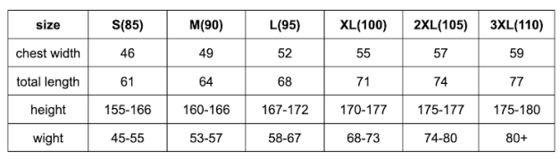
(한 개만 표시)
S
M
L
XL
2XL
3XL

10. Have you entered all the information correctly?
Yes, I have.

11. Do you have any serious physical disability that prevents you from walking, running, or participating in sports activities?

No, i don’t 13번째 질문으로 건너뛰세요
Yes, i do. (/Maybe) 12번째 질문으로 건너뛰세요

⚠️ This page is for those who answered 'Yes (/Maybe)' in the last question.

12. If you do have any serious physical disability, please specify below.

13. Do you have any dietary restrictions?

No, I don't. 15번째 질문으로 건너뛰세요.
Yes, I do. 14번째 질문으로 건너뛰세요.

⚠️ This page is for those who answered 'Yes' in the last question.

14. If you do have dietary restrictions, please specify below.
ex) I can't eat meat.

(Optional)
If there's a friend you'd like to be on the same team with, please write their name below.
⚠️ We may not be able to accommodate all requests.

15. * Name of the friend (Full name would help)

